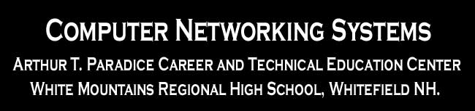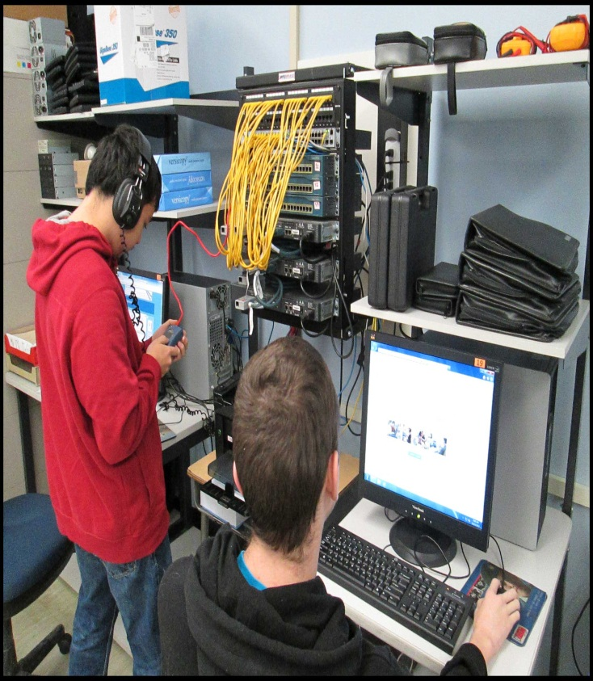

Students who complete both years of the Cisco Networking Program will earn 17 College Credits through the Running Start Program!   
Many colleges have acccepted our students, including but not limited to:

**UNH Durham NH ~ NHTI Concord NH. ~ SNHU Manchester NH ...and many more!**

**Earn College Credits While In High School**

* Advanced Troubleshooting Skills.
* Installation & Configuration of Network Topologies.
* Managing & Maintaining a Computer Network.
* Teamwork & Leadership Skills.

**WMRHS**

**LEARN MORE ABOUT A CAREER IN COMPUTER NETWORKING**

Students programming Cisco Routers and Switches.

**Cisco Networking Students Learn**

The first year of this program prepares students for a career in computer networking. This course will provide students with classroom and laboratory experience in current and emerging network technologies. Instruction includes networking terminology and protocols, network standards, LANs, WANs, OSI Model, cabling, cabling tools, routers, router programming, star topologies, IP addressing and the network administrator's role and function. The course is taught using the Cisco Systems Networking Academy Curriculum.

This course is a continuation of Computer Networking I, covering IP Version 6, LAN design with bridges, routers and switches, Fast Ethernet, Spanning Tree Protocol, Virtual LANs and LAN Trunking. The topic of wireless broadband is also covered. Extended coverage of WAN, Frame Relay, ISDN, PPP, HDLC and DDR will also be covered. The course also covers advanced features of Packet Tracer. The course is taught using the Cisco Systems Networking Academy Curriculum: Cisco Exploration LAN Switching and Wireless and Accessing the WAN.

**Computer Networking**

**Grade 12**

**Computer Networking**

**Grade 11**

**127 Regional Rd ~ Whitefield NH 03598 ~ Phone 603-837-2528 ~ rdanault@sau36.org**